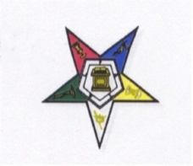
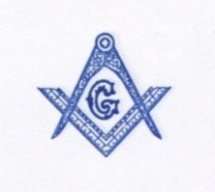
2014 CONVENTION COMMITTEE
FOR THE
M.W.P.H. GRAND LODGE F. & A.M., COLORADO
&
IT’S JURISDICTION
AND
COLUMBINE GRAND CHAPTER O. E. S. (PHA)
P. O. BOX 1276
Aurora, Colorado 80040-1276
************************************************************************************************************************
REGISTRATION FORM
AUGUST 9 – 12, 2014
(Please print)

NAME: Sis/Bro______________________________________ Phone#_________________ Date______

ADDRESS:________________________________CITY____________________STATE____ ZIP_____

Registration Fee: $75.00 for all attendees.
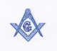
Deadline for registration is July 15, 2014 PLEASE NOTE ON SITE REGISTRATION WILL BE $125.00 No refund will be given for cancellations received after July 15, 2014.

Lodge Name & No.___________________________________________ City ______________________ State____
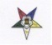
Chapter Name & No._________________________________________ City ______________________ State____

Please select ONLY ONE OFFICE for your name tag.

Are you a? PAST GR Master____ GR Matron ____ Master ____ Matron _____ Patron____

GRAND LODGE OFFICER: YES_______ NO_____ Office______________________________________

LODGE OFFICER: YES_______ NO_____ Office______________________________________

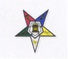
GRAND CHAPTER OFFICER: YES_______ NO_____ Office______________________________________

CHAPTER OFFICER: YES_______ NO_____ Office______________________________________

Arrival Date: _________________________Time: ________AM________PM_______ Departure Date:________

Banquet selection: Seared Chicken Breast________ Broiled Top Sirloin________ Vegetarian Meal______

********************************************ADDITIONAL TICKET INFORMATION****************************************

Extra Banquet Ticket Meals_______ @ $40.00 each Total Amount Due: $ ________

Banquet Selection: Seared Chicken Breast (#) ______ Broiled Top Sirloin (#) ______ Vegetarian Meal (#) ______

TOTAL AMOUNT ENCLOSED: $ _____________ CHECK ---MO--CASH

Make Checks/Money Orders payable to:

2014 Prince Hall Convention Committee

MAIL TO: 2014 Prince Hall Convention Committee
P. O. Box 1276
Aurora, Colorado 80040-1276

