***November Preemie Babies Project is still ongoing. Our goal is to crochet/knit 200 hats for neonatal units at the local and/or national hospitals as needed.***

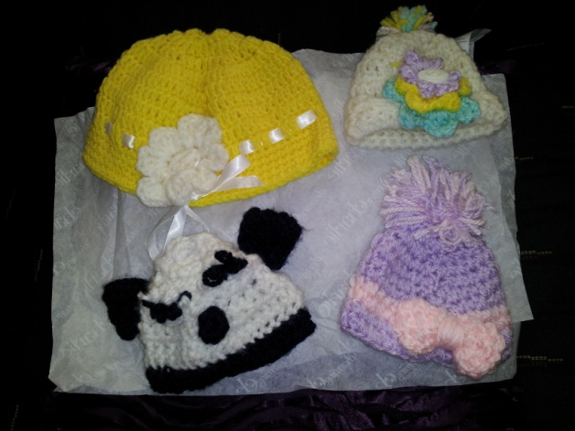

**From the Desk of the Past** **Matrons/Patrons Committee**

**Preemie Beanie Baby Hats**

*From the Desk of the Worthy Matron:*

*Greetings Sisters and Brothers,*

*Happy summer to all! Love the Lord your God with all your heart, all your soul, and all your mind*

*– Matthew 22:37.*

*The 92nd Annual Grand Chapter Session is right around the corner and will be held here in our great city of Colorado Springs,*

*CO August 10-12, 2014 at the Colorado Springs Marriott Hotel, 5580 Tech Center Drive, Colorado Springs, CO 80919. Registration fee for all attendees is $75.00. Deadline is July 15, 2014 afterward the cost will be $125.00. This is an opportunity to learn, grow, see ritualistic work performed and to show support to* ***our Grand Worthy Matron, Lillian H. Favors*** *and Columbine Grand Chapter O.E.S. (P.H.A). Also, volunteers are needed to help with various activities i.e. BBQ, hospitality, etc. Please contact Sis Associate Matron, Carol Foster.*

*Magnolia Chapter is strongly committed to Sisterly Love giving back to each other and the community. As stated in our Chapter Theme: Time is here – to go back to basics and promote charity, unity, respect, and love by giving back to the community and each other. This issue of the Newsletter focuses on community involvement and activities. You can help greatly by donating items, sharing your time and showing your support. I encourage all of you to get involved with your Chapter.*

*Magnolia is doing great things we initiated three new sisters and two new brothers: Sis Kiy-Afrie Collins, Sis Monique Brown, Sis Carrie Daniels, Bro Stanley Brooks and Bro Tariq Collins. Please seek out these new members and get to know them.*

*Let’s continue to move forward and have a successful year. Don’t forget to give a sister or brother a call that has not been attending regular meeting. Enjoy serving the Lord and He will give you what you want – Psalm 37:4. In closing, I challenge each of you to give the Chapter your utmost support and continue to Love One Another!*

*Blessings & Sisterly Love,*

*Charlene J. Perry*

*Charlene J. Perry*

*Sis Charlene J. Perry*

*Worthy Matron*





**School Supply Drive**

C:\Users\dorothy.f.bell\AppData\Local\Microsoft\Windows\Temporary Internet Files\Content.IE5\KOFBS3IS\MC900446284[1].wmf

**Helen Hunt Elementary School is the school chosen this year to be sponsored by our Chapter. We are requesting donated items to be provided not later than 8 Aug so they can be delivered to the school prior to opening on 18 Aug. A complete listing of items needed, will be included in the email sent out this week.**

C:\Users\dorothy.f.bell\AppData\Local\Microsoft\Windows\Temporary Internet Files\Content.IE5\YSOZTJRW\MC900412400[1].wmf



Volume2, Issue 2 April – June 2014

MAGNOLIA CHAPTER #14

OES QUARTERLY NEWSLETTER



***BIRTHDAY SHOUT OUTS***

***MAY EMERALDS***

**FRIENDLY REMINDER**

**Magnolia Chapter #14 OES Website is available at**

[**http://www.magnoliachapter14oes-pha.com/**](http://www.magnoliachapter14oes-pha.com/)

**Nursing Home Visitation**

The second visit to The Gardens Nursing home will take place on 27 Sept; time is to be determined. More information to follow.

**Food Pantry Drive**

This an ongoing project to help support any Sister in need. As of today, this committee does not have a listing of anyone needing our help, so if you know of someone, please provide Sister Sadie Jackson, Sister Raynor or WM Perry with her name and we will contact her. The food items will be disbursed quarterly to a Food Bank if there are no Sisters needing our help.

Homeless Care Packages

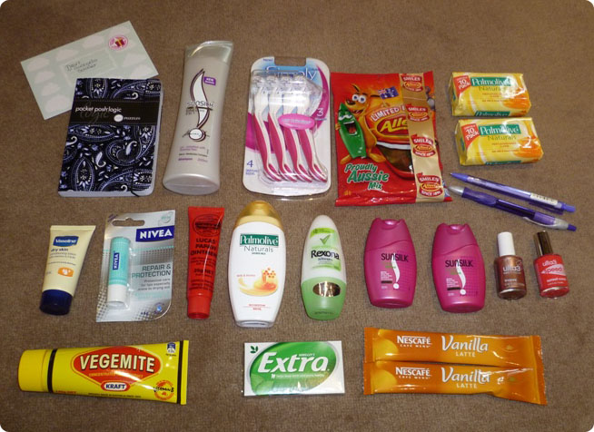

We are requesting donations for hygiene type items (face towel, soap, toothpaste, toothbrush, shampoo, deodorant, lotion, etc) by 19 July. Consolidation of the items will take place directly after our workshop on 26 Jul. For those Sisters/Brothers that can make it, we will deliver the packages to Emmanuel Missionary Baptist Church prior to 2:30 on 26 Jul, who will deliver them to homeless individuals at numerous locations on that same day. Our goal for this event is to donate ___ packages, so anything you can provide will be greatly appreciated.

**BIRTHDAY SHOUT OUTS**

**APRIL DIAMOND**



***"She who from April dates her years,   
Diamonds shall wear, lest bitter tears  
For vain repentance flow."***

***Sis Bobbye Freeman, 1 Apr***

***Sis Carol Foster, 11 Apr***

***Bro John Bennett, 13 Apr***

***PGP Jack Beverly, 13 Apr***

***Sis Lorena Thomas, 13 Apr***

***Sis Betty Raye, 15 Apr***

***Sis Janie Williams, 16 Apr***

***Sis Jacklyn Raynor, 30 Apr***

**BIRTHDAY SHOUT OUTS**

**JUNE PEARLS**

***"Who first beholds the light of day  
In spring's sweet, flower month of May  
And wears an Emerald all her life  
Shall be a loved and a loving wife."***

***PM Cozetta Thomas, 2 May***

***Sis Demetria Martinez, 9 May***

***Bro Samuel Perry, 11 May***

***Sis Dorothy Bell 26 May***

***Sis Netanya Jamieson, 27 May***

***"Who comes with summer to this earth  
And owes to June her hour of birth  
A pearl should wear against her skin  
Who's innocence many a heart shall win."***

***Sis Kyla Curtis, 10 Jun***

***Bro Edward Davis, 18 Jun***

***Sis Michelle Dewberry, 14 Jun***

