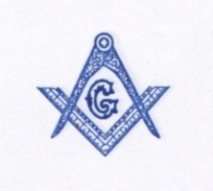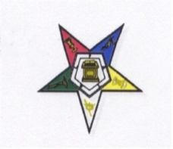
2014 CONVENTION COMMITTEE
FOR THE
M.W.P.H. GRAND LODGE F. & A. M., COLORADO
AND
IT’S JURISDICTION
AND
COLUMBINE GRAND CHAPTER O.E.S. (P.H.A.)
P. O. BOX 1276
AURORA, COLORADO 80040-1276
February 15, 2014
Concordant Bodies of Colorado and its Jurisdictions

Greetings:
Hear ye! Hear ye! The 138th Annual Grand Lodge Session and the 92nd Annual Grand Chapter Session of the MWPHGL of Colorado and It’s Jurisdictions will be held August 10th – 12th, 2014 in Colorado Springs, Colorado at the
Colorado Springs Marriott Hotel
5580 Tech Center Drive
Colorado Springs, Colorado 80910
Single or Double Occupancy …..$99.00
These rates are subject to sales tax
Register under group name Prince Hall Grand Lodge
Telephone: 719-260-1800

If you are planning on attending, please register with the hotel as soon as possible, but no later than July 10, 2014 to receive the group rate for Prince Hall Grand Lodge.
The registration fee for the convention is $75.00 for all attendees. Included in the fee will be one (1) Banquet ticket, a social gathering (Saturday), and some great items. Please send your registration form to: Prince Hall Convention Committee, P. O. Box 1276, Aurora, CO., 80040-1276. Deadline for registration is July 15, 2014. Please Note: On-site registration will be $1250.00. No refund will be given for cancellations received after July 15, 2014. Registration time: (TBD) Times to be determined.

A Souvenir Journal ad is provided in this packet and the committee respectfully solicits your support by advertising your business, lodge, chapter or your personal ad in this year’s souvenir journal. Also enclosed is a vendor contract. We hope you will fully participate in this year’s activities.

Thank you in advance for your support and participation.

Fraternally,
Grand Lodge/Chapter
Convention Committee

